DeluXe website Template CONTENT FORM

IMPORTANT INFORMATION YOU NEED TO KNOW PRIOR TO FILLING OUT THIS WEBSITE CONTENT FORM:

- Our Web Development Team will NOT accept this website content form and will ONLY start working on your website if 100% of content is submitted (including logo and pictures).

- All content MUST be submitted at once.

- Timeframe for completion of website is 6 to 8 weeks from the day we receive 100% of content requested on this form. Any further requests after submitting your content will be deemed as chargeable and shall delay the completion of website.

- ONLY once website is complete, one of our Web Developers will contact you and provide you with the website URL for your final revision.

GENERAL Information

WHAT iS INCLUDED on your deluxe template:
- Home Page
- Search Page
- About Us
- Contact Us
- Services
- Fubble Attraction Ticket Widget (If you do not have properties in Florida, we can replace the Fubble page with a static Local Area Guide/Information Page)
- Terms and Conditions
- Privacy Policy

SELECT website TEMPLATE CHOSEN:
☐ WT1001 (http://wt1001.ciirus.com/)
☐ WT1003 (http://wt1003.ciirus.com/)
☐ WT1004 (http://wt1004.ciirus.com/)
☐ WT1006 (http://wt1006.ciirus.com/)
☐ WT1007 (http://wt1007.ciirus.com/)
☐ WT1008 (http://wt1008.ciirus.com/)
☐ WT1009 (http://wt1009.ciirus.com/)

will you purchase or renew your ssl certificate?
THE SSL CERTIFICATE (secure socket layer) is NOT INCLUDED, BUT highly recommendED for your website.
Why do i need an ssl certificate?
The SSL Certificate protects your sensitive information such as credit card information, usernames, passwords, and so on. It also keeps data secure between servers, increases your google rankings, and builds/enhances customer trust.
* If your website is secured with the SSL Certificate, guests will not be able to confirm a booking on your website if they do not provide a credit card to process the payment.
* If your website is not secured with the SSL Certificate, guests will be able to confirm a booking on your website even if they do not provide a credit card to process the payment.
The SSL Certificate must be purchased/renewed by your company since we do not have the ability to purchase/renew it on your behalf. Once you are in process of purchasing/renewing your SSL Certificate, please send an email to websites@ciirus.com and we will be able to provide you with the CSR that will be requested for completion of certificate purchase/renewal.

are you interested in selling attraction tickets through FUBBLE on your website?
Fubble is a third-party ticket company that will allow your guest to purchase tickets for theme parks. Once they purchase tickets from your site you will get a percentage of the commission on the tickets bought.
If you select YES, we can get you in contact with an Agent that will be able to provide you with more information.
Here is a link to a video explaining what Fubble is/offers: https://vimeo.com/217168411
Should you wish to contact a Fubble team member directly, do so at sales@fubble.com .
IF YOU DO NOT HAVE PROPERTIES IN FLORIDA. PLEASE FILL OUT THE INFORMATION FOR THE
LOCAL AREA GUIDE/INFORMATION PAGE:

Local Area Guide/Information Title:
Page Image Suggestions (if applicable):
Page Content:

Would you like to use the blogging facility?
Select YES if you would like to use the blog facility in your system which will allow you to create your own blog posts for your website
Here is a video tutorial on how to add blog posts in your system (blog starts at 3:47): https://vimeo.com/159805713
If you do not want blogs on your site, please select NO so we can hide this option from the menu.

What would you like the main color and accent color of your website to be?
Main Color (example: top menu background color, footer): #
Accent Color (example: buttons): #
Please provide us the color in hexadecimal format (i.e #ffffff )
Here is a link that can help you find the color code: http://www.w3schools.com/colors/colors_picker.asp
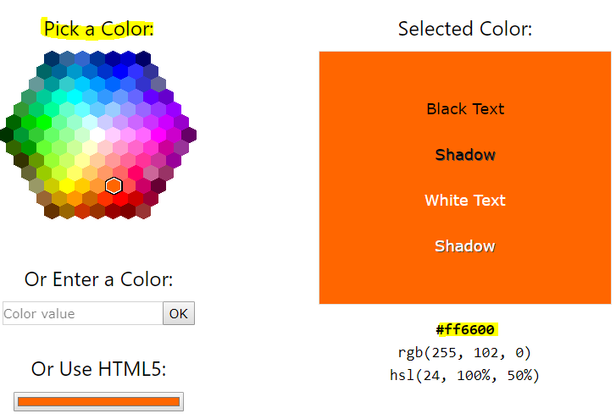
important information regarding pictures or videos for your website:
1. Your logo must be in a .PNG or .AI format
2. We do own a license with Adobe Stock (https://stock.adobe.com/) so we offer you the option to send us your own pictures/videos and/or choose pictures/videos from Adobe Stock and provide us with the file numbers. There is no charge for pictures; however, please note that videos are chargeable at $79 per video.
Also keep in mind that time lapse videos are not recommended as they can slow down your site extensively.
If you would like to provide any images of your own, please send this to us by either a drop box link or attached to this Content Form once completed. If you would like to provider your own Video. Please send this to us in either MP4 or MOV format, 1920 x 1080 & if possible no longer than 20 seconds length.
Add your Drop Box Link here:

Home Page
Please refer to your chosen template for an idea of the ‘Home Page’ section.
Example (if template WT1001 was chosen): http://wt1001.ciirus.com/
You may add up to 4 images or up to 3 videos on the banner.

home page slider images File number
- Image/Video:
- Image/Video:
- Image/Video:
- Image/Video:

Welcome text
Please refer to your chosen template for an idea of the ‘Welcome Text’ section. This text may be up to 250 characters max.
Welcome Text Title:
Page Image (if applicable):
Page Content:

Testimonials
Please refer to your chosen template for an idea of the ‘Testimonials’ section. You may include up to 4 testimonials. (Include Name, Date/Country at the each of each review)
Review 1:
Review 2:
Review 3:
Review 4:

Search page
Please refer to your chosen template for an idea of the ‘Search Page’ section.
Example (if template WT1001 was chosen): http://wt1001.ciirus.com/search.aspx?&incmap=1
Search Page Title:
Search Page Welcome Text (If applicable):
Please check the below filters that you would like on the Search Page.

Filters:
☐ Location (All locations automatically pull once configured in the system – please see the following tutorial on how to add your locations: https://vimeo.com/232997862)
☐ Check In (As Date)
☐ Check Out (As Date)
☐ Guests (As Dropdown)
☐ Bedrooms (As Dropdown)
☐ Property Types (As Dropdown)
☐ Conservation View (As Check Box)
☐ Water View (As Check Box)
☐ Privacy Fence (As Check Box)
☐ Air Conditioning (As Check Box)
☐ Club House (As Check Box)
☐ Community Pools (As Check Box)
☐ Free Calls (As Check Box)
☐ Full Kitchen (As Check Box)
☐ Grill (As Check Box)
☐ Laundry In Unit (As Check Box)
☐ Pets Allowed (As Check Box)
☐ Private Pool (As Check Box)
☐ Spa (As Check Box)
☐ Wi-Fi (As Check Box)
Please list any filters you would like that are not listed on above below: (Each custom feature is an additional cost of $25 per feature).

property DETAILS PAGE: /details.aspx

Note:
Most of the data for the property details pages pull from the system. Please make sure you fill out your plaintext, add all your images and configure your rates. Also, if your properties are bookable online, please make sure to fill out your terms and conditions, assign them and check the box to allow online bookings. This page is automatically created when you add a property and these items will only appear if populated in the system.
For more information on how to do this, please view our system training tutorials here on setup -
Training Session 1:
Configuring Software Settings
Adding Properties / Property Assistant

Services page
Please refer to your chosen template for an idea of the ‘Services Page’ section.
Example (if template WT1001 was chosen): http://wt1001.ciirus.com/content/services.aspx
You may list up to 4 services that you offer to feature on this page.
Should you wish not to offer any services, please write (HIDE THIS PAGE) on the Page Tile.
(If you have any optional services that you offer to the guest, these can be added as Cart Extras in the system to show on the Booking Page. Please see the tutorial on how to add cart extras - Cart Settings)
Page Title:
Services Welcome Text: (200 characters max.)
Service 1:

Service 2:

Service 3:

Service 4:

About Us page
Please refer to your chosen template for an idea of the ‘About Us’ section.
Example (if template WT1001 was chosen): http://wt1001.ciirus.com/aboutus.aspx
Page Title:
‘About Us’ Image (If applicable):
About Us Text: (600 characters max.)

Contact Us page
Please refer to your chosen template for an idea of the ‘Contact Us’ section.
Example (if template WT1001 was chosen): http://wt1001.ciirus.com/contactus.aspx
Page Title:

Contact info:
Address:

Phone Number:
Email:

Footer

SOCIAL MEDIA
Only fill in with the URL of each social media your company has.
Facebook:
Twitter:
Pinterest:
Google +:
Linked in:
YouTube:
Instagram:
GitHub:
Tumblr:
Trip Advisor
Snapchat:
WhatsApp:

Terms and COnditions page

Title:
Text:

Privacy Policy page

Title:
Text:

Additional comments/requests

Please use this section to add any additional comments or questions that you have.
If you would like to make any modifications or add any updates that are not currently on the template, please list them below. Your developer will then be in touch with a quote and timeline for these requests.
* Please note that your website will take up to 6 to 8 weeks for completion from date of submission of 100% of the content requested above. Any additional modifications will push back the competition date for the website.

important information prior to submitting this form

- Please review all content added to this form prior to submitting to our team. Keep in mind that we will not start working on your website if we do not receive 100% of content requested on this form, including logo and pictures.
- Please attach any pictures/videos, also attach your logo in a .PNG or .AI format once you submit the form by email to websites@ciirus.com

I agree by providing this information, that the images and text are my own, or have been approved for use on my website. I acknowledge that stealing information is illegal and that CiiRUS Inc. is not responsible for the information I provide.

Date:

Name (Printed):

Signature:

